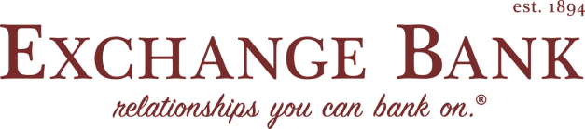
Omaha Commercial Loan officer:
Join our team at Exchange Bank. We are a growing $1 Billion Nebraska-based and family owned bank dating back to 1894. Exchange Bank is an emerging bank in Omaha and our team is committed to ensuring that customers receive the highest quality and most responsive service in the Omaha metro. We empower our staff to be the catalyst and to add value as a trusted financial partner to our customers. If you aspire to do the same, we’d like you to advance your career with us at Exchange Bank.
JOB DESCRIPTION
We are seeking a seasoned commercial lender that is interested in spending more time making loans and adding value for our customers and less time navigating the bureaucracy of a corporate lending process. Responsibilities include developing a prospect list for new commercial lending relationships, analysis and evaluation of financial statements and cash flows, cultivating existing relationships for new loans, develop and present loan recommendations on credits exceeding assigned lending authority. Applicant must have proven business development skills, involvement in community activities and organizations.

ESSENTIAL FUNCTIONS
- Underwriting, analysis and presentation of financial statements and tax returns for credit decision.
- Facilitate loan closing by explaining all documents to customers and obtaining required signatures.
- Recommend other Exchange Bank products and services to meet bank budget goals and lender key accountabilities and refer to the appropriate area to best serve our customer’s needs.
- Establish relationships including real estate brokers and builders and leading small business prospects for C&I and CRE loans, presenting information to professional groups within the community, and maintaining a high degree of visibility for Exchange Bank in the Omaha market.
QUALIFICATIONS
- Bachelor’s Degree or equivalent work experience.
- 5 years minimum commercial/business banking experience.
- Knowledge of underwriting, cash flow and credit analysis and closing procedures.
- Experience with federal lending regulations governing real estate lending.
- Accuracy and meticulous attention to detail required.
- Strong reconciliation skills.
- Advanced negotiation skills.
- Excellent oral, written, and interpersonal communication skills.
- Ability to manage multiple requests simultaneously while meeting deadlines, and flexibility to change direction as needed.
- Team-oriented and the ability to work collaboratively across all levels of the organization.
Service focused
- Advanced problem-solving and analytical skills.
All qualified applicants will receive consideration for employment without regard to race, color, religion, sex, sexual orientation, gender identity or national origin.
Job Type: Full-time

Experience:
- Commercial Lending – Minimum 5 years (Preferred)
Additional Compensation:
- Exchange Bank discretionary bonus program
Work Location:
- One location
Benefits:
- Health insurance
- Dental insurance
- Vision insurance
- Retirement plan
- Paid time off
Management:
- Some Leadership

